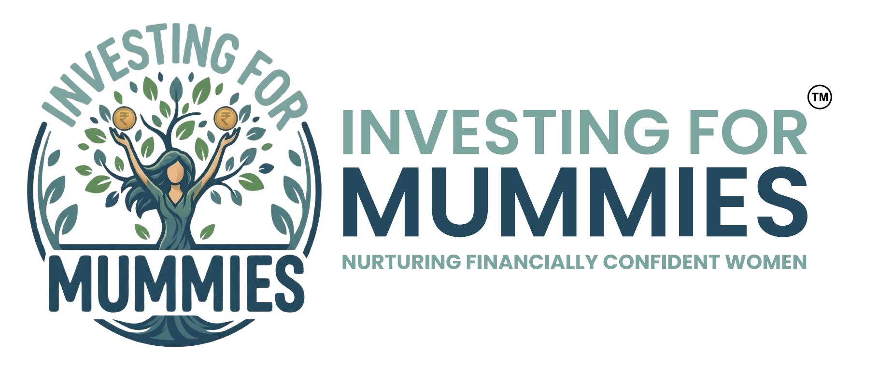
WORKSHOP PROPOSAL
The Wealth Conversation
The Why, The How & The Where of Investing — a 2.5-hour interactive workshop that makes investing feel simple, practical and completely doable.
Prepared for: Sonakshi Agarwal
Proposal date: 13 July 2026
Workshop at a Glance
WORKSHOP | The Wealth Conversation — The Why, The How & The Where of Investing
DATE | Friday, 31 July 2026
TIME | 3:00 PM – 5:30 PM
DURATION | 2.5 hours, inclusive of Q&A
FORMAT | Live, interactive session with games, calculators and exercises
AUDIENCE | Forum members — no prior investing knowledge needed
INVESTMENT | ₹40,000 — all-inclusive, GST included
About Investing for Mummies
Investing for Mummies (IFM) is a financial education platform that makes money conversations feel as natural as a chat with a friend. No jargon. No judgment. Just clarity, confidence and action.
We specialise in making investing genuinely enjoyable — through interactive games, simple calculators and real-life examples grounded in Indian investment products and Indian household realities. Our sessions are warm and playful, but always credible: every game and exercise is built on real financial principles.
Meet Hiral Goel
A graduate of the University of Michigan, Ann Arbor in Communications, I spent over a decade as a business journalist with Business India magazine, where I covered India's corporate landscape and had the privilege of interviewing some of the country's most respected business leaders. I also helmed the magazine's flagship Businessman of the Year Award, bringing together a distinguished jury and writing the cover story on each year's awardee.  As a mother of two, I eventually became more involved in my own family's financial planning. That's when I realised something surprising—despite spending years writing about India's most respected businesses, I didn't know how to manage my own money. |   Hiral Goel · Founder
I discovered that many women shared the same experience. We were educated, successful in our careers, and capable of earning money, yet few of us had been taught how to invest it with confidence.
That realisation inspired me to start Investing for Mummies.
Today, I conduct workshops for women and corporate organisations that simplify investing and build financial confidence. Through practical examples, relatable analogies, and interactive learning, my goal is to help women become informed, confident, and equal participants in their family's financial decisions.
“I believe that if women are capable of earning their own money, they are absolutely capable of learning how to grow and manage it too.”
Workshop Structure
The workshop is structured into three key sections — The Why, The How and The Where of Investing — and is designed to simplify concepts that often feel intimidating or overwhelming.
SECTION 01 The Why — Why investing matters
We begin by understanding why investing is necessary in the first place. This section focuses on:
- Understanding inflation and why simply saving money is often not enough
- Learning how inflation impacts long-term goals
- Using simple inflation calculators to practically understand the math
- Experiencing the power of compounding through interactive games and exercises
SECTION 02 The How — The 3 Bucket Investment Strategy
This section introduces a simple yet powerful framework for organising investments through the 3 Bucket Investment Strategy:
- Emergency Bucket — The money you can reach in a crisis — parked safe and liquid.
- Stability Bucket — The money that keeps your life steady — low-risk, dependable growth.
- Growth Bucket — The money that builds long-term wealth — invested for the future.
Participants will learn how different investments serve different purposes, and how this framework brings structure, clarity and confidence to financial decision-making.
SECTION 03 The Where — Understanding asset classes
In the final section, we introduce the different asset classes and what they represent:
- The role and characteristics of various asset classes — and where each one fits within the three buckets
Session Flow
TIME | SEGMENT
3:00 – 3:10 | Welcome & warm-up
3:10 – 3:55 | The Why — inflation, goals, calculators & the compounding game
3:55 – 4:35 | The How — the 3 Bucket Investment Strategy
4:35 – 5:05 | The Where — asset classes and where they fit
5:05 – 5:30 | Q&A and key takeaways
What Participants Walk Away With
The strongest takeaway from this workshop is that participants will leave with a new way of thinking about money and investing:
- A practical understanding of why investing matters
- A simple framework to begin organising their finances
- Greater confidence in making informed financial decisions
- The ability to start approaching money with clarity, purpose and long-term thinking
Investment
₹40,000
All-inclusive · GST included · No additional charges
This covers:
- The full 2.5-hour facilitated workshop, inclusive of Q&A
- All interactive games, calculators and exercise materials used in the session
Next Steps
To confirm the workshop, simply reply to this proposal and we will lock in Friday, 31 July 2026, 3:00 – 5:30 PM for your forum. We look forward to starting the Wealth Conversation with your members.
Hiral Goel · 9867026583 · hiral@investingformummies.com

Investing for Mummies · investingformummies.com · @investingformummies

